

Anekant Education Society’s

**Tuljaram Chaturchand College of Arts, Science and Commerce (Autonomous), Baramati.**

**A**

**PROJECT REPORT**

**ON 4 th April 2022**

**“Blood Bank Managment System”**

**Submitted to Savitribai Phule Pune University, Pune. For T.Y.B.Sc. (Comp.Sci.)**

**By :**

**Name  Markad Pruthviraj Dattatray (Roll No. _12124 )**

**UNDER THE GUIDANCE OF**

**Your Guide Name  Prof Kalyani Londhe**

**Academic Year : 2021 – 2022**



Anekant Education Society’s

**Tuljaram Chaturchand College of Arts, Science and  Commerce(Autonomous), Baramati.**

**CERTIFICATE**

This is to certify that the project entitled “**Blood Bank Managment System”** submitted by **Markad Pruthviraj Dattatray** in partial fulfillment of the requirement of the  award of degree B.Sc.(Comp.Sci.) to Savitribai Phule Pune University, Pune has  been carried out by them under my guidance satisfactorily during the academic  year 2021-2022.

Date : 04/04/2022

**INDEX**

|  |  |  |
| --- | --- | --- |
| **Sr. No.** | **Title** | **Page No.** |
| 1 | Problem Definition |  |
| 2 | Scope of System |  |
| 3 | System Requirement |  |
| 4 | Feasibility Study |  |
| 5 | E-R Diagram |  |
| 6 | Class Diagram |  |
| 7 | Component Diagram |  |
| 8 | Sequence Diagram |  |
| 9 | Activity Diagram |  |
| 10 | Input Output Screens |  |
| 11 | Future Enhancements |  |
| 12 | Conclusion |  |
| 13 | Bibliography |  |

**Problem Solving:**

It is difficult to maintain a hardcopy of records. To search, delete or to update information of any record is very difficult to solve this problem and to overcome such issues we have created this online Blood Bank Availability System by using this system it is easy to find any particular records details very easy to update or delete records. The Systems is user friendly and affordable.

**Scope of the System:**

The main purpose of the project to build an application program to reduce manual work for managing information of blood groups. The aim is to automate its existing manual system with help of computerized equipment and computer software fulfilling their requirements. It tracks all the information of blood donor, blood acceptor, blood groups and etc.…

It may help collecting perfect management of Blood Bank Availability System. The System is absolutely easy to understand. Easy to operate, secure.

**System Requirement:**

. A good device with active internet connection.

. A user with little knowledge of computer system.

Hardware requirement:

1) Processor: -Pentium 4

2) Operating system: -Window XP

3) RAM: -256MB

4) Hard disk: -80GB

**Feasibility study:**

1. The feasibility study is conducted to select the best that meets the required performances.
2. The main objectives of a feasibility study are to test the technical, operational and economical feasibility of developing computer system.
3. This is done by investigation of existing system in the area under investigation and generating ideas about new system.

Feasibility Study are as follows-

1)Operational Feasibility:

The system is user friendly and it is menu driven system and much easier to operate the interface of the system and the screen display is quite clear. There are menus by which the user can be led to system operation.

2)Technical Feasibility:

This involves the study how to handles the machine. So, the technical feasibility means to the employee for the better performance and reduce time of working.

3)Economical Feasibility:

The system is going to reduce the time and human requirement, it should to be financially and economically feasible. The technique of cost benefit analysis is often use as a basis for assessing economic feasibility. This feasibility shows the manpower cost.

**ER Diagram:**

Blood Bank Managment System

**has**

hh

U_PASS

U_ID

user

R_DATE

R_NAME

R_ID

m

H_NAME

**Blood Receiver**

manages

H_ID

RH_FACTOR

BL_GRP

BL_GRP

**Hospital**

ACCEPTS

RH_FAC

H_DATE

LAST_DATE

Give

**BLOOD**

BL_GRP

**Class Diagram:**

|  |
| --- |
| **User** |
| **U_ID**  **U_PASS** |
| **MANAGES_HOSPITAL ()**  **MANAGES_RECEIVER()** |
| **1**  **manages**   |  | | --- | | **Receiver** | | **R_ID**  **R_NAME**  **BL_GRP**  **RH_FACTOR**  **R_DATE** | | **RECEIVE_BLOOD ()** |   **M**  **Accepts** |

|  |
| --- |
| **Hospital** |
| **H_ID**  **H_NAME**  **BL_GRP**  **RH_FACTOR**  **D_DATE**  **LAST_DATE** |
| **DONATES_BLOOD ()** |

1 M

**manages**

**Donates**

|  |
| --- |
| **Blood** |
| **BL_GRP** |

|  |
| --- |
|  |

**Component Diagram:**

**Hospital**

Dd

**Blood Bank Managment**

**System**

**Receiver**

Data access access

Data access

Data access

**System Admin**

**Database**

**Display**

Sequence Diagram:

Log In

Report

Accept Blood

Request Blood

Report

Accept Blood

Check Blood

Log In

Activity Diagram:

End

Logout Form System

Manage Report

Manage receiver registration

Check permission

Check permission

Check permission

Check user level and permission

Login to Blood Bank System

Manage hospital registration

Input Pages:

Home page:

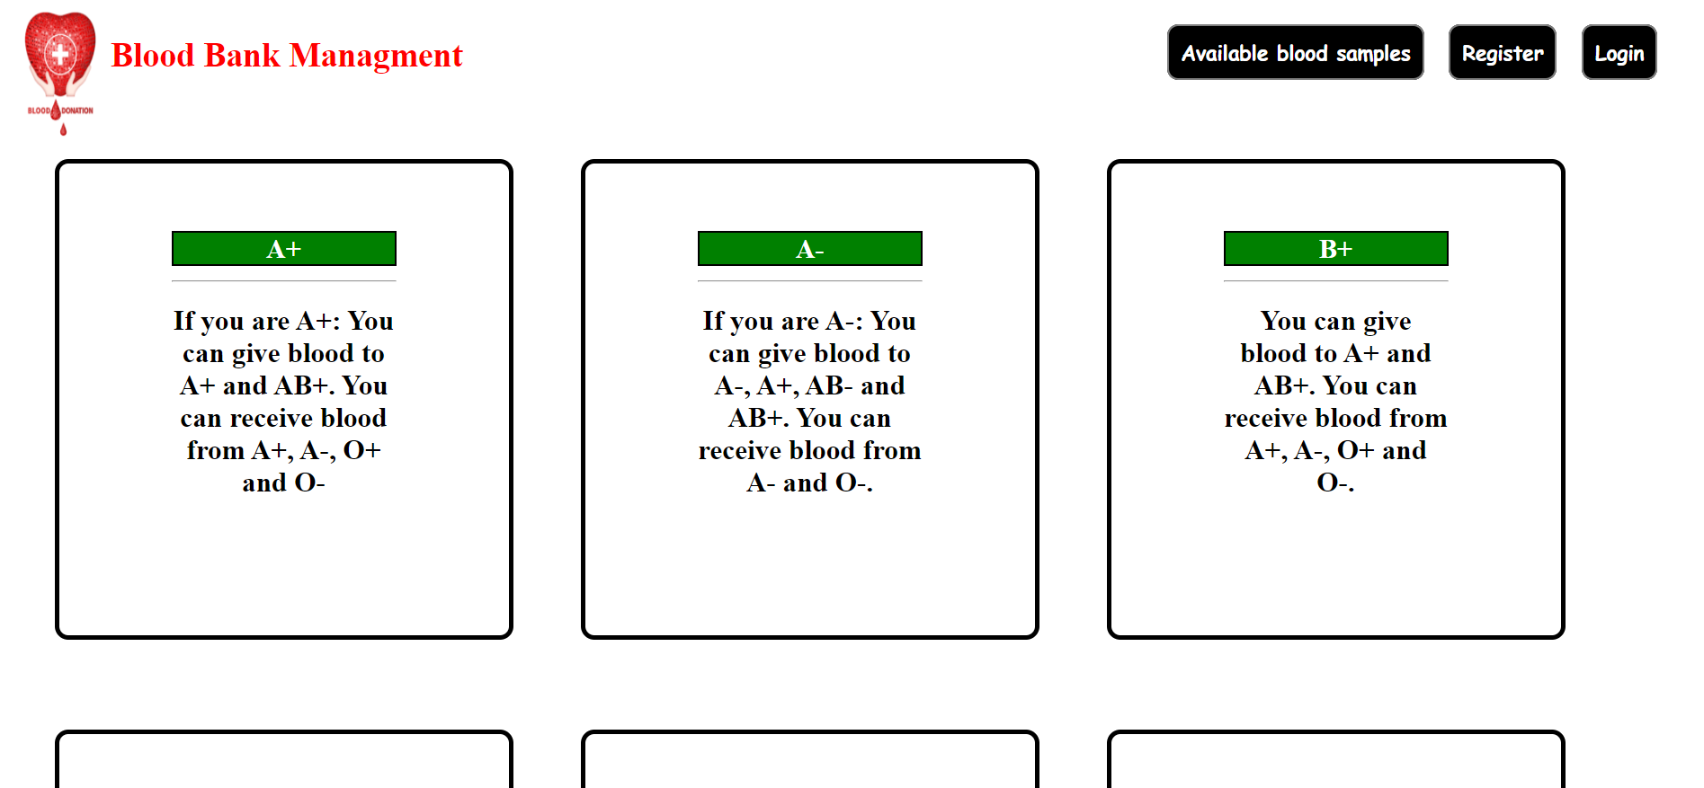

Hospital and Receiver Registration:

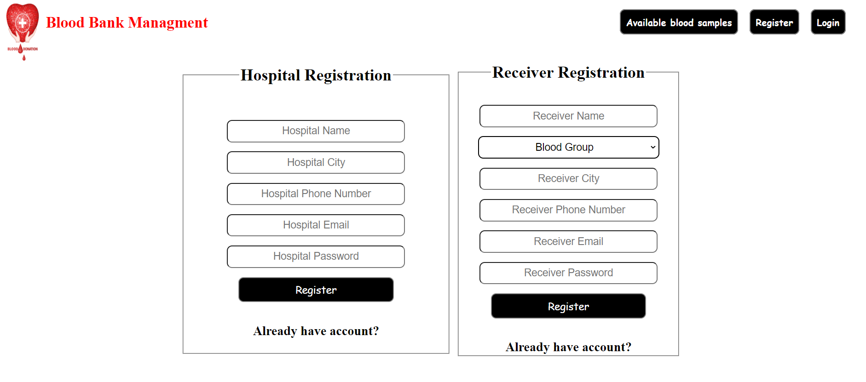

Receiver Login Page:

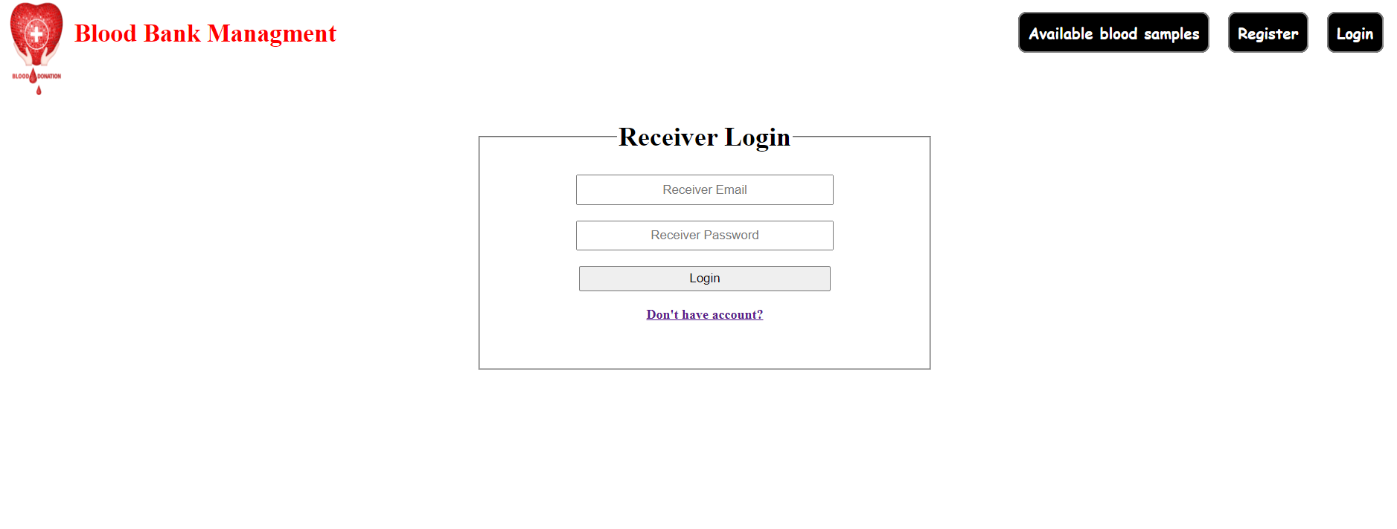

Hospital Login Page:

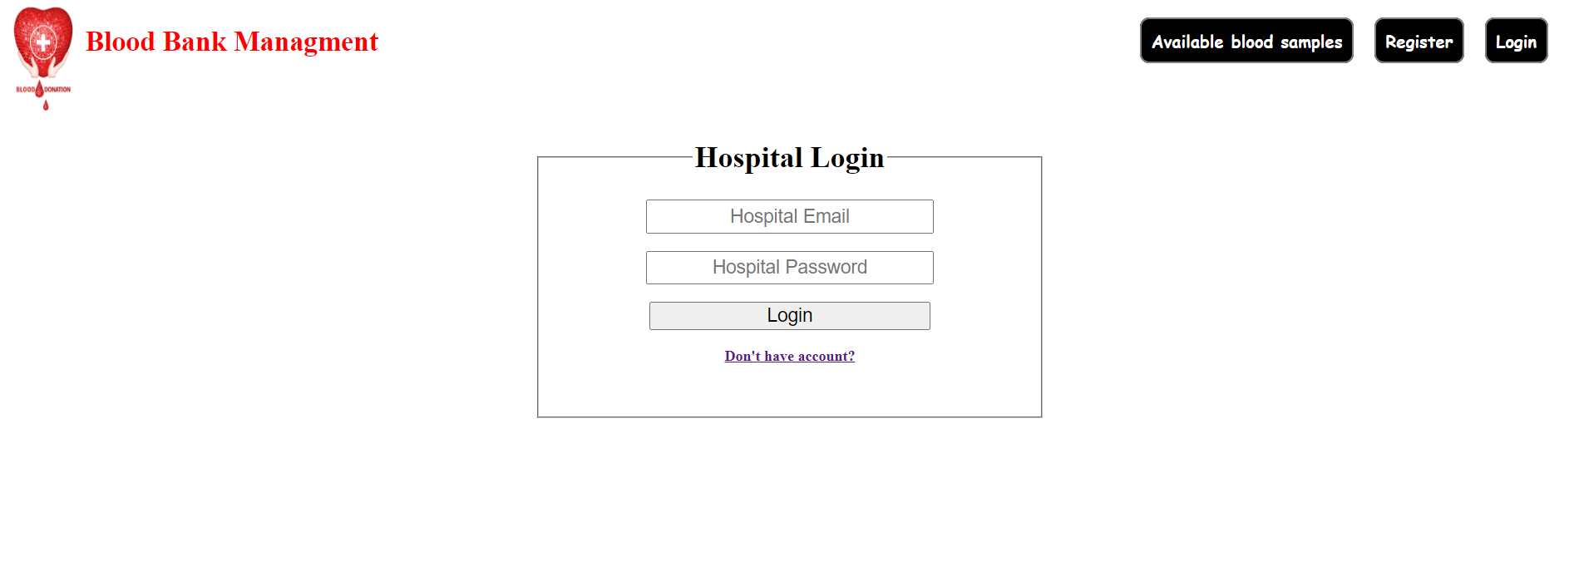

Receiver Sucessful Login:

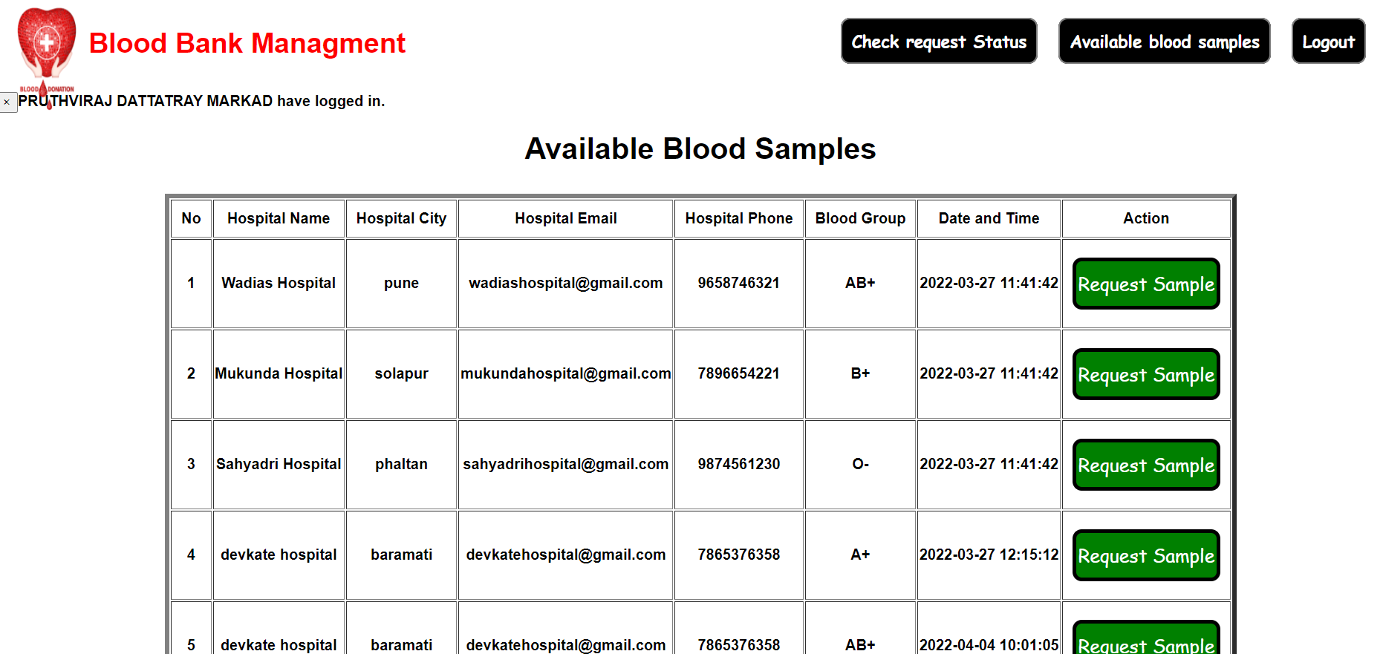

Hospital Sucessful Login:

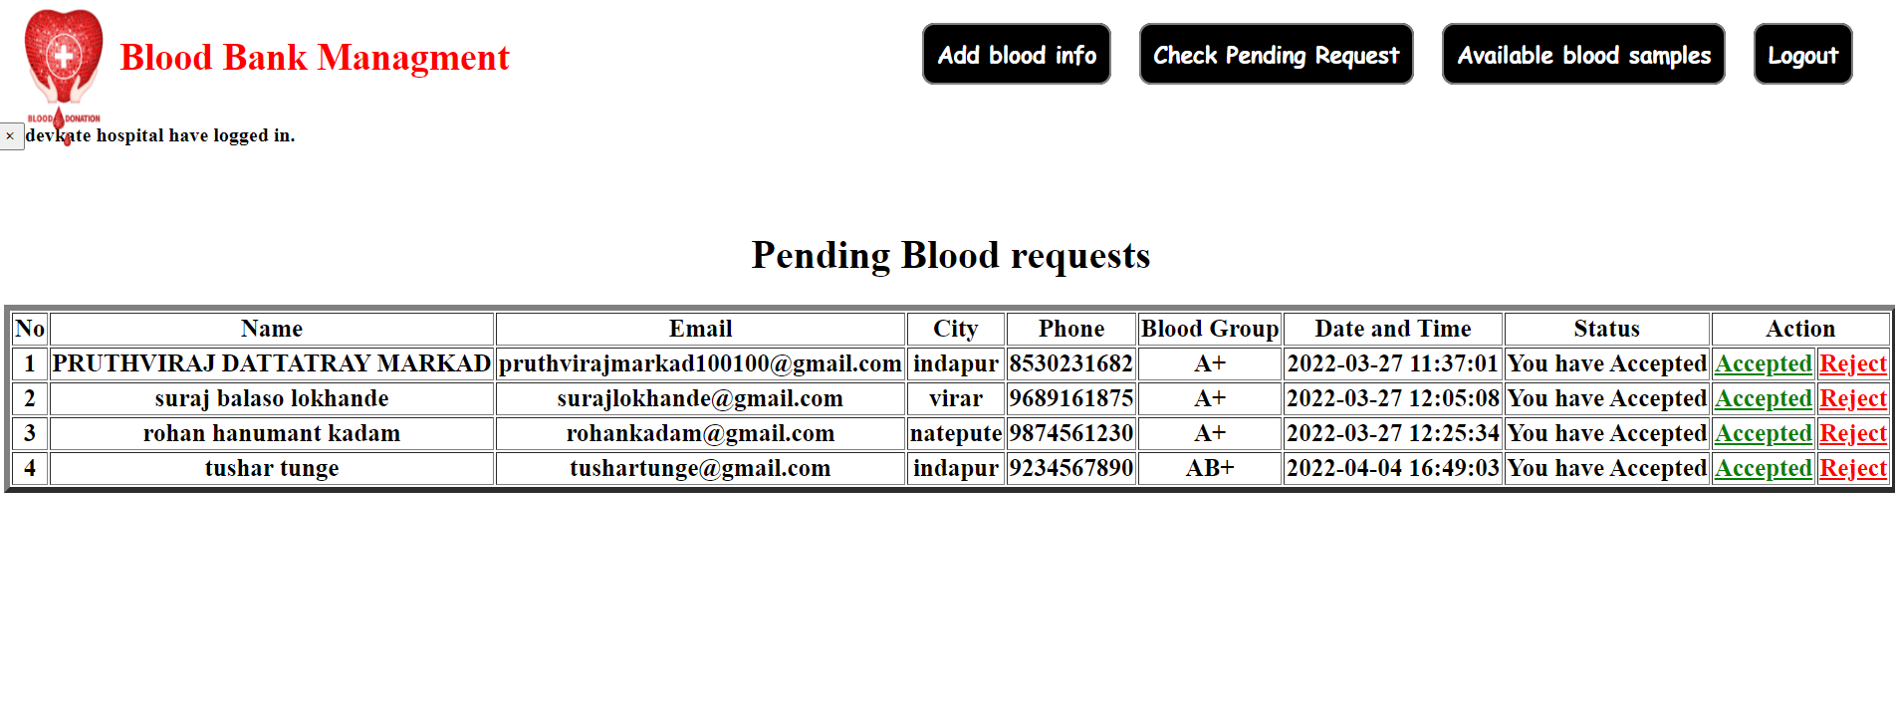

Report Layout:

Available Blood Sample:

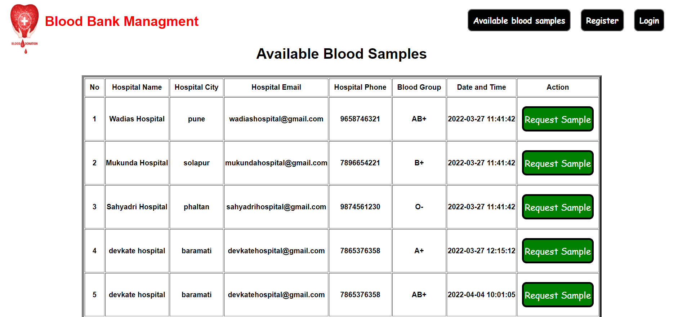

Receiver Blood Request Status:

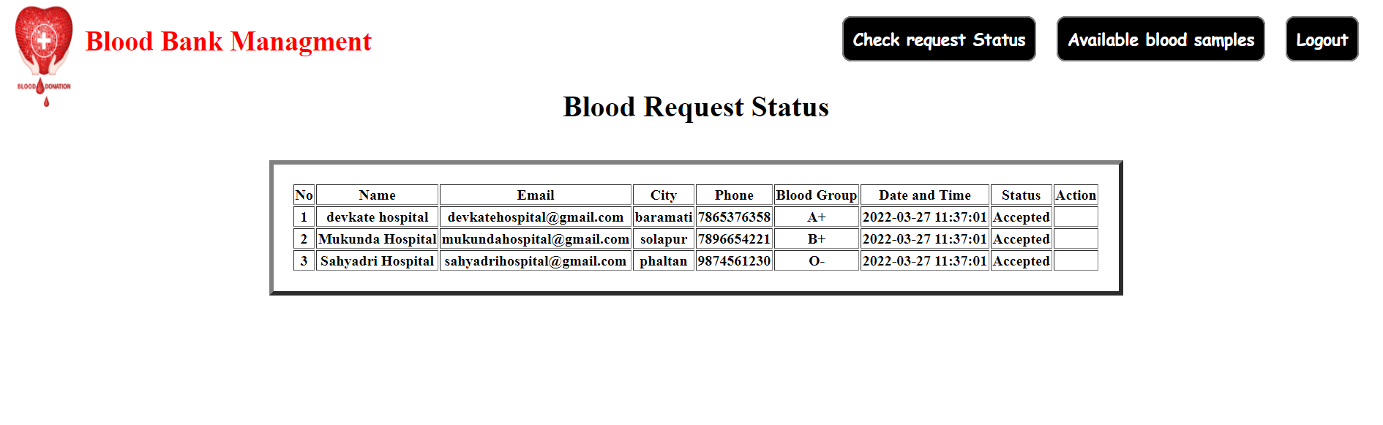

Pending Blood Request:

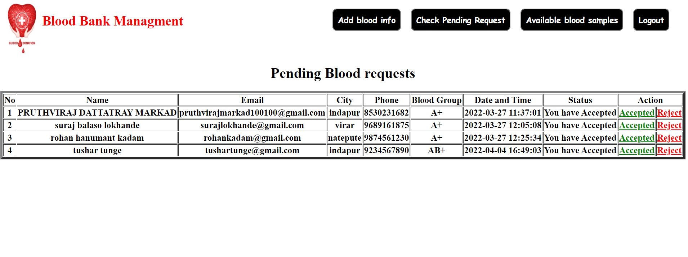

Hospital Available Blood:

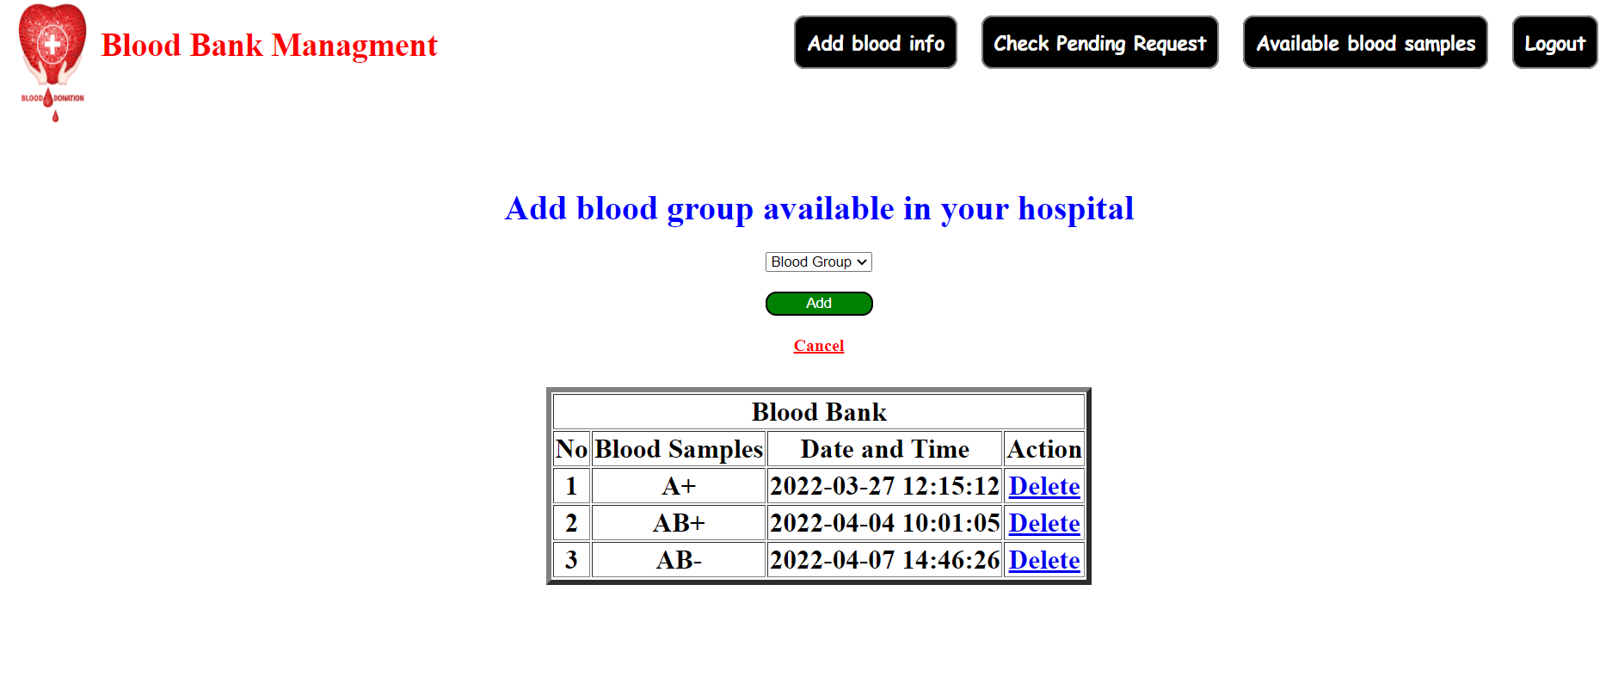

**Future Enhancements:**

In near future we are planning to update are system little bit and some new features which will help user to search details of blood bank online.User can also message module.

**Conclusion:**

This “Blood Bank Availability System” helps user to get information about donar,acceptor,etc.

Simillarly this package also gives following facilities:

Addition of new records.

Update of existing records.

Fast and easy access of forms and records.

**Biblography:**

1. [www.w3school.com](http://www.w3school.com)
2. Wekipedia.org
3. www.projectz.org